QUEUE SIMULATION FOR MINIMIZING CLIENTS WAITING
TIME

Șutea Adrian

Group 30425

Table of contents

1. Objective

1.1 Description . . . . . . . . . . . . . . . . . . . . . . . . . . . . . . . . . . . . . . . . . . . . . . . . . . . . . . page 3

2. Problem analysis. . . . . . . . . . . . . . . . . . . . . . . . . . . . . . . . . . . . . . . . . . . . . . . . . . . page 4

3. Diagrams

3.1 UML Class diagram . . . . . . . . . . . . . . . . . . . . . . . . . . . . . . . . . . . . . . . . . . . . . . . page 5

3.2 UML Use-case diagram . . . . . . . . . . . . . . . . . . . . . . . . . . . . . . . . . . . . . . . . . . . . page 7

3.3 UML Sequence diagram. . . . . . . . . . . . . . . . . . . . . . . . . . . . . . . . . . . . . . . . . . . . page 7

3.4 UML Activity diagram . . . . . . . . . . . . . . . . . . . . . . . . . . . . . . . . . . . . . . . . . . . . . . page 8

4. Implementation

4.1 Implementation and testing . . . . . . . . . . . . . . . . . . . . . . . . . . . . . . . . . . . . . . . . . .page 8

4.2 Implementation details . . . . . . . . . . . . . . . . . . . . . . . . . . . . . . . . . . . . . . . . . . . . . page 9

5. Conclusions . . . . . . . . . . . . . . . . . . . . . . . . . . . . . . . . . . . . . . . . . . . . . . . . . . . . page 11

6. Bibliography . . . . . . . . . . . . . . . . . . . . . . . . . . . . . . . . . . . . . . . . . . . . . . . . . . . . page 11

Objective
Design and implement a simulation application aiming to analyze queuing based systems for determining and minimizing clients’ waiting time.

1. 1. Description
Design and implement a simulation application aiming to analyze queuing based systems for determining and minimizing clients’ waiting time. Description Queues are commonly seen both in real world and in the models. The main objective of a queue is to provide a place for a "client" to wait before receiving a "service". The management of queue based systems is interested in minimizing the time amount its "clients" are waiting in queues. One way to minimize the waiting time is to add more servers, i.e. more queues in the system (each queue is considered as having an associated processor) but this approach increases the costs of the supplier. When a new server is added the waiting clients will be evenly distributed to all current available queues.
The application should simulate a series of clients arriving for service, entering queues, waiting, being served and finally leaving the queue. It tracks the time the clients spend waiting in queues and outputs the average waiting time. To calculate waiting time we need to know the arrival time, finish time and service time. The arrival time and the service time depend on the individual clients – when they show up and how much service they need. The finish time depends on the number of queues, the number of other clients in the queue and their service needs.
Input data: - Minimum and maximum interval of arriving time between clients;
- Minimum and maximum service time;
- Number of queues;
- Simulation interval;
- Other information you may consider necessary;
Minimal output: - Average of waiting time, service time and empty queue time for 1, 2 and 3 queues for the simulation interval and for a specified interval;
- Log of events and main system data;
- Queue evolution;
- Peak hour for the simulation interval;
For interacting with the user, the application has an graphic user interface based on the Java Swing.

Problem analysis
For modelling the application we must determine the entities and the way of implementation. I have identified the next entities that must be implemented in this kind of application:
Scheduler Class – this class is the most important in this application because it is the one which creates a new client generator and adds each client to the server which has the smallest queue. Another functionality of this class is that it updates the text area in the graphical user interface when the simulation has finished with the average waiting time and average service time for each queue.
Generator Class – this class is the one responsible with generating a number of clients for the simulation. For testing I have chosen two hundred clients to be generated, but their number is not so important as long as it is not too small, otherwise the simulation will stop sooner than expected.
Server Class – the most important attribute of this class is the Blocking Queue which has a fixed size that can’t be exceeded. For testing I chose the size to be 5 (that means that only 6 clients can be at a server’s queue), but this number can be modified in any way without affecting the application’ s behaviour. The main functionality of this class is selecting the client on the top of the queue and „serve” it, this is done until the simulation time is over. Also, this class updates the text area in the graphical user interface each time a client is being served and also when the serving was finished.
Client Class – this class has as attributes the service time, arrival time and an ID. It has getters for all it’s attribues and a setter for the arrival time. This class implements Runnable and in it’s run() method it has a sleep thread declaration, which puts the client to „sleep” for a time equal to it’s service time .
Gui Class – this class is responsible with creating the graphical user interface. It has some text areas for writing the arrival interval, the service interval and the simulation time, and a big text area where a logger is created. In the right part of th interface there is a panel on which the actual simulation is done, on this panel a label is added each time a client arrives at a queue and the label is removed when the client leaves (has been served). The start simulation button creates a new swing worker in which a new scheduler is created and also creates a timer which shows how much time has passed since the simulation started.

Main Class – this class creates an instance of the Gui class in order for the whole program to be able to run.

More information about the functionality of these classes will be presented in the „implementations details” sections of this document.

Diagrams
The program has six classes separated into two packages: the gui package and the queues package. The gui package contains only the Gui class. The queues package contains: the Scheduler class, the Generator class, the Server class, the Client class and the Main class.

3.1. UML Class Diagram
The class diagram with the relationships between classes is shown below.
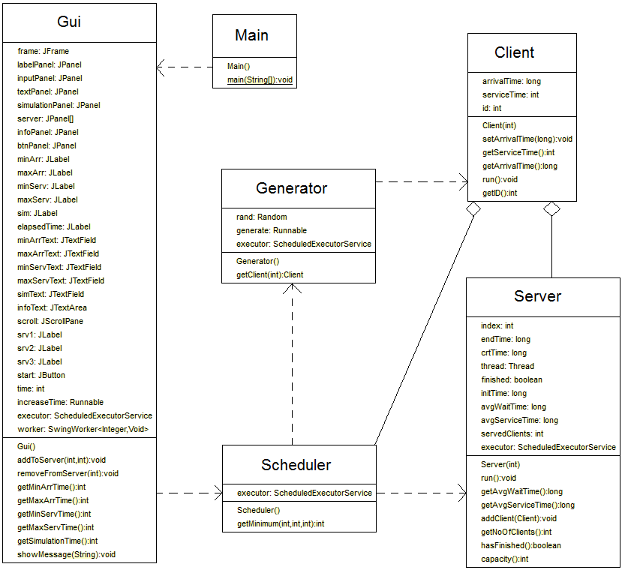

Relationships between classes

The Main class is responsible for creating the Gui class (graphic user interface) and it has a dependency relationship with it. Because the Gui class creates a new scheduler when the start button is pushed, a dependency relationship exists between the Gui and Scheduler classes. The Scheduler class has two dependency relationships with the Generator class and the Server class because it creates both of them. Another dependency realtionship is between the Generator class and the Client class for obvious reasons (the generator generates a number of clients). Between the Scheduler and the Client there is an inheritance relationship because the scheduler is responsible with adding each client to a server. An inheritance realtionship is also between the Server class and the Client class because each server contains a queue of clients.

3. 2. UML Use-case diagram
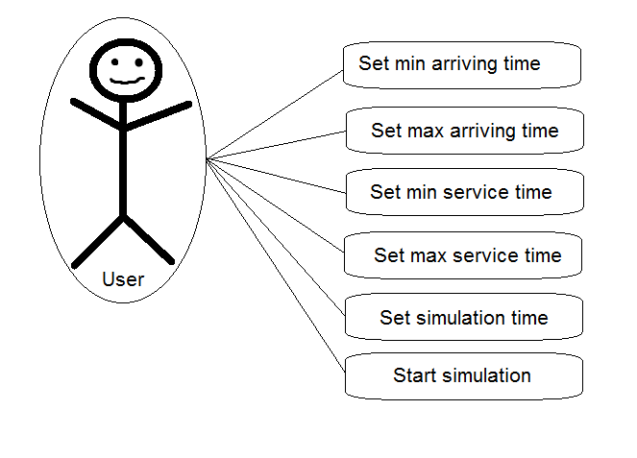
3. 3. UML Sequence diagrams
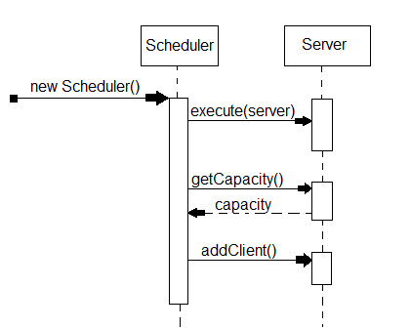

3. 4. UML Activity diagrams
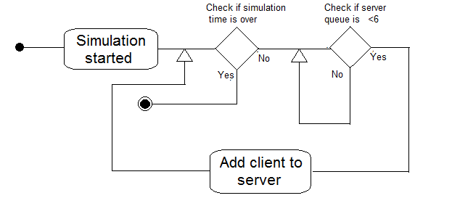

Implementation

4. 1. Implementation and testing
In what the implementation is concerned this project was developed in Eclipse and it was only tested in this environment. However the program should maintain its portability. Concerning the code implementation I did not make use of laborious algorithms, but I have rather stayed faithful to the classical algorithms. However I have tried to implement my problem in a way that appears to me as being the most efficient one, that is why I have changed my model at first.
Testing implies checking for any errors in the program or limitations of this program. Due to the fact that the program is rather simplistic, there are few errors that might make this program to work wrong or to stop. This errors are mostly related to the interface. I have assumed that the user reads the instructions from the interface and respects them, otherwise if he enters data with invalid format the program will probably generate some bugs and will stop. Hence this part with checking all the possible scenarios will be seen as future development.

4. 2. Implementation details
Class design:
Scheduler Class – this class has as attributes three servers, a client generator a client and an executor. The executor is of type scheduled thread pool and it can execute a maximum of 3 threads at a time. In the class’s constructor, the start time is initialized using the system current time function and the end time is set as the sum between the start time and the simulation time which is took from the graphical user interface. After that the client generator is created, the three servers are created and executed using the declared executor and each server gets one initial client. Then a while loop is executed until and the simulation time is over and all the servers have finished their current clients, in this loop a client is taken from the generator and is added to the server with the smallest queue size as long as this size isn’t bigger than six, otherwise it will wait. After the while loop is finished, for each server it will be shown, in the text area in the graphical user interface, it’s average waiting time and average service time.
Generator Class – this class has as attributes an array list of clients, a random number which will be used for setting the arrival time of each client and an instance of a Runnable which will generate a client using the exeuctor. The constructor of this class contains a for loop which calls the executor that executes the run method that creates the clients and adds them to the array list. This class also contains a method named getClient that receives as parameter an integer and it returns the client found in the array list at the position specified by that integer.
Server Class – the most important attribute of this class is the Blocking Queue which has a fixed size that can’t be exceeded, but it also has as attributes the start time, end time, an instance of a Thread and an index. The constructor of this class gets as parameters an integer which will be set as the server index. Due to the fact that this class implements the Runnable interface, it contains the run method in which we find a while loop that loops until the simulation time has finished. In this loop, a client is taken from the queue, a new thread is created with that client and a message is shown in the text area of the graphical user interface, saying that the client is being served, immedately after that the thread is started and with the join() method we make sure that the server will wait for the thread to finish. After the thread has thread has finished executing, the client’s arrival time is added to the arrival time average, the client’s service time is added to the service time average, the counter that counts the number of clients served is incremented, a message is shown in the text area in the graphical user interface saying that the client has been served and the client’s label is removed from the interface. This class has getters for the average service time, for the average arrival time and for the capacity of the queue, it also has a method addClient() that receives as parameter a client, tries to add him to the queue and if it manages to it also adds that client’s label to the interface.
Client Class – this class has as attributes the service time, arrival time and an ID. It has getters for all it’s attribues and a setter for the arrival time. The constructor of this class has as parameter an integer which will be set as the client id, also, in the constructor the clients’ service time is set as a random number between the minimum and maximum service time written in the text areas in the graphical user interface. Due to the fact that this class impements the Runnable interface, it has a run method in which the thread (the client) is put to sleep for a time equal to the client’s own service time.
Gui Class – this class is responsible with creating the graphical user interface. It has some text fields for writing the minimum arrival time, the maximum arrival time, the minimum service time, the maximum service time and the simulation time, and a big text area where a logger is created where every event is marked. In the right part of the interface there is a panel on which the actual simulation is done, on this panel a label is added each time a client arrives at a queue and the label is removed when the client leaves. The start simulation button creates a new swing worker in which a new scheduler is created and it also starts the execution of a scheduled thread pool which contains a thread that increases a variable at each second, and it actually creates a timer which counts the time that has passed since the simulation has started. I have used a swing worker for creating a new scheduler because otherwise the graphical user interface would freeze until the simulation would finish. The Gui class contains getters for all the values written in the text fields, a show message method that receives as parameter a string which will be added to the end of the text area and an add to server method that gets as parameter two integers, one specifies the index of the server that the label should be added to and one is the index of the client to be added, the method will create a new label and add it to the simulation panel.

Main Class – this class creates an instance of the Gui class in order for the whole program to be able to run.

Conclusions
The hardest part of this project wasn’t actually the threads part, because their implementation is pretty simple, but it was simulating the queue in the graphical user interface. I say that was the hardest part because the first time I tried to do it the whole gui would freeze when I pushed the start simulation button. I have done some research and found that that was happening because the button would wait for the actions performed in the action listener to finish, and in my case that happens only when the simulation finishes, thus the graphical user interface won’t update until the simulation finishes. For dealing with that problem I have used a swing worker, which actually creates a new thread for the operation performed in the action listener and this way the gui now can be updated freely.
As further developments this application could include:

- The possibility of having a variable number of servers.
- The possibility for a server to close, and for the clients waiting at that server to be distributed to the other servers.
- There could be added a functionality that if all the queues are full a new server will automatically be created.
- The possibility for a client to leave a queue and go to one in which he would have less clients in front of him.

Bibliography

https://www.javacodegeeks.com/2013/01/java-thread-pool-example-using-executors-and-threadpoolexecutor.html - from here I learned how to work with executors and thread pool executors
http://www.tutorialspoint.com/java/java_multithreading.htm - from here I learned how to work with threads
http://www.javacreed.com/swing-worker-example/ - from here I learned how to work with the swing worker

